**CHAPTER 3  
TECHNICAL BACKGROUND**

The Technical Background serves to provide essential context and detail on the research methodology employed. It outlines the specific technical tools, instruments, and approaches used to conduct the project. This chapter typically includes details on data collection methods, research instruments, software, hardware, or other technical resources. By offering this technical background, it enables readers to comprehend the practical aspects of your research, ensuring transparency and clarity in your methodology.

**RESEARCH APPROACH**

The developers used combined quantitative and qualitative methods in this project and uses mixed methods as their research design, which aims to provides a more comprehensive understanding of the needs and expectations of website users, ultimately leading to a more effective and user-friendly website in their capstone project. The data validation process will involve a thorough review of the data collected to ensure its accuracy and reliability.

The Data Collection Instruments used in this project include Surveys/Questionnaires, Interviews, and Observations. The researchers will use Surveys/Questionnaires to gather quantitative data about the organization's needs and preferences for the website. This could include questions about content, design, functionality, and user preferences. On the other hand, they will use Qualitative Interviews with stakeholders or potential website users can provide in-depth insights into their expectations, pain points, and requirements which can help them understand the "why" behind their responses in surveys. They will also use Observations to provide valuable insights into how users interact with websites and what usability issues may arise.

The Data Analysis Technique used in this project will be Descriptive statistics which help the researchers to summarize and present quantitative data about user preferences, behaviors, or feedback in a clear and straightforward manner. It provides an overview of your data, highlighting key trends and patterns that can inform website design decisions and improvements. Descriptive statistics can include measures like averages (mean), percentages, and frequency distributions. Statistical Analysis Software such as Excel and SPSS are also used as these tools will analyze the collected data and generate meaningful insights. We will present the results clearly and concisely, using tables, graphs, and charts to illustrate key findings.

The project management system will be developed based on the specific needs and requirements of the client. The goal of the proposed system is to create a platform for the client where organization administrators can easily upload and manage their documented COP (Community Outreach Program) Activities, as well as efficiently handle student activity proposals. Additionally, it aims to offer users a way to stay informed about COP-related posts, events, and news from the CES (Community Extension Service).

**SYSTEM REQUIREMENT**

The system requirements are the configuration of the system in order to properly run hardware or software, failure to meet the system requirements can cause compatibility errors, installation errors, and performance errors or it may cause the software or hardware to not work at all. For Hardware Requirements, the developer includes minimum and recommended specification for each component such as Processor, RAM, Storage/Disk Space, and Wi-fi Router. Whereas, the Minimum specification serve as a baseline or a set of standards that ensure a certain level of quality, compatibility, or performance of a system, while the recommended specification provide users with guidance on what equipment or devices will deliver the best experience when using software or applications. These recommendations are based on the optimal performance and functionality of the software. These hardware requirements define the necessary physical components and capabilities a computer or device must have to run the software or system effectively.

On the other hand, the developer recommended in the Software Requirements that the website should be compatible with the most recent versions of web browsers, including Chrome on Windows, macOS, and Linux, Safari, Firefox, and Edge. This approach emphasizes the importance of keeping computer or device system requirements up to date to ensure a seamless user experience.

**HARDWARE REQUIREMENTS**

Hardware requirements for Users:

|  |  |
| --- | --- |
| **Components** | **Minimum & Recommended specifications** |
| Processor | Minimum of 3GHz, Recommended: 4GHz |
| RAM | Minimum of 4GB, Recommended: 8GB |
| Storage/Disk Space | Minimum of 3GB, Recommended: 4GB |
| Wi-fi Router | Minimum of 5Mbps, Recommended: 10Mbps |

**Table 3.1  
USERS HARDWARE REQUIREMENTS**

Hardware requirements for Administrations:

|  |  |
| --- | --- |
| **Components** | **Minimum & Recommended specifications** |
| Processor | Minimum of 3GHz, Recommended: 4GHz |
| RAM | Minimum of 4GB, Recommended: 8GB |
| Storage/Disk Space | Minimum of 500GB, Recommended: 1TB |
| Wi-fi Router | Minimum of 5Mbps, Recommended: 20Mbps |

**Table 3.2  
ADMINISTRATORS HARDWARE REQUIREMENTS**

**SOFTWARE REQUIREMENTS**

|  |  |
| --- | --- |
| **Web Browsers** | **Recommended Version** |
| Chrome on Windows | Any latest version |
| Chrome on macOS |
| Chrome on Linux |
| Safari |
| Firefox |
| Edge |

***Table 3.3*  
SOFTWARE REQUIREMENTS**

For best performance, Instructure products should be used on the current or previous major releases of Chrome, Firefox, Edge, or Safari. Because Instructure products are built using web standards, Instructure products run on Windows, Mac, Linux, or any other device with a modern web browser, according to the article of Instructure Community (2023) entitled “What are the browser and computer requirements for Instructure products?”.Instructure products only require an operating system that can run the latest compatible web browsers. Your computer operating system should be kept up to date with the latest recommended security updates and upgrades.

**REQUIREMENT ANALYSIS**

The researchers defined these criteria for their system, which is a web-based application accessible via web browsers. To determine these criteria, the researchers conducted research to find the optimal hardware and software prerequisites for web-based applications using browsers. They also conducted interviews, posing a set of questions to gather information that would assist in the system's development.

**RESEARCH METHODOLOGY**

This capstone project aims to develop a Community Online Resources Engaging System that will help the CES department to have a modern approach. The research methodology section of this study will provide an in-depth discussion of the techniques, approaches, and designs used throughout the study to reinforce the decisions made and evaluate the advantages and disadvantages of each approach to the research objectives. The study will be divided into four stages: project design, development, operation and testing, and evaluation of the proposed system. Each stage will be critical to the success of the research and development process and will be carefully executed to ensure that the proposed system is effective and efficient.

The project design stage is a formulation of the study's research question, objectives, and scope and where the data collection methods are determined in addition, the research design was chosen to be a qualitative research design, as it was deemed the most appropriate for this study due to the exploratory nature of the research. This stage also involved identifying the potential participants and obtaining their consent to participate in the study.

However, the project development stage is the phase where the system was designed and created in accordance with the requirements gathered in the project design stage. This process utilized various software development tools and techniques to bring the system to fruition.

During the operational and testing phase, the system underwent rigorous testing for both its functionality and user-friendliness. A diverse set of test cases was employed to verify that the system satisfied its specifications and performed as expected. Any problems or glitches discovered during this phase were promptly addressed, and the system was reevaluated until it met the prescribed standards.

In the evaluation phase, the suggested system underwent an assessment to gauge its effectiveness and efficiency. This step entailed collecting feedback from participants regarding their experiences with the system and analyzing the gathered data to ascertain if the system aligned with the research objectives. In essence, the research methodology employed in this study was carefully designed to offer a comprehensive comprehension of the subject under examination, all the while ensuring that the proposed system was methodically and rigorously developed and assessed.

**PROJECT DESIGN**

The Project design for Community Online Resources Engaging System (CORES) will be based on the storyboard created. The following steps are required to implement the system properly: (1)Begin by outlining the system's requirements, which involves collecting data from stakeholders and recognizing potential constraints or limitations that could impact the project and then Finalize once all the materials are gathered and prepared. (2) Start to assess the system thoroughly and complete the design phase, which includes the creation of comprehensive navigation bar, visual user interfaces, and other documentation to clearly outline how the system will operate. (3) Proceeding to the coding phase, where the developers will perform all the specified requirements and designs. This entails writing code, integrating third-party tools and libraries, and configuring various components of the system. (4) After the coding is complete, it's crucial to perform rigorous testing to ensure accuracy and alignment with the established plans. This testing should encompass both functional and non-functional assessments to verify that the system performs as intended and meets all specified requirements. Any issues uncovered during testing should be documented and resolved prior to deploying the system in a production environment.

**PROJECT DEVELOPMENT**

Once the purpose of making the system and objectives have been placed, the following steps compose the project development process: (1) **Defining the foundation,** (2) **Crafting the Blueprint** (3) **Prototyping** (4) **Testing** (5) **System** **Evaluation.**

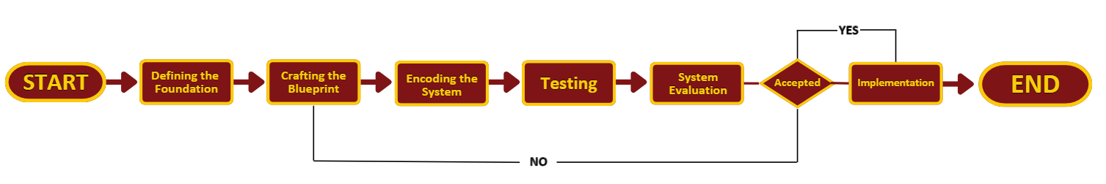

**Figure 3.1**  
**PROJECT DEVELOPMENT**

**DEFINING THE FOUNDATION**

After defining the system's objectives, the next step is to strategize and refine the focus by selecting the critical issues that will serve as the core foundation for the system development process. This Phase is a critical starting point that aims to provide a deep understanding of why the project is needed and what benefits it can bring to its intended beneficiaries. It involves comprehensive research and planning to clarify the project's objectives and scope. Additionally, it considers the project's potential to contribute to broader global goals and positive change. This phase sets the project's direction and establishes its justification for implementation.

Users, especially administrators and students, frequently encounter significant challenges when attempting to communicate news or events within the community and manage their documentation of all the conducted Community Outreach Programs (COP) at the University of Perpetual Help System Dalta (UPHSD). The observed concerns include the following: (1) Limited Community Awareness: The community lacks sufficient information regarding the organization's recent developments and activities; (2) Minimal Engagement and Feedback: There is a notable scarcity of active participation and feedback from community members regarding the conducted activities; (3) Disorganized Documentation: The absence of a centralized and well-structured documentation system hinders easy access to files and data, making it difficult for people to view documents when needed; and (4) Difficulty in Concept Paper Submission: Students face significant hurdles when trying to submit concept papers for departmental approval to conduct Community Outreach Programs.

By highlighting these critical issues mentioned above, the developers can pinpoint the project's foundation. This allows for a smoother transition into the next phase, which involves creating a website that addresses the clients' needs and provides solutions to their problems. Finally, the project’s foundation is identified and reviewed before proceeding to craft the system design.

**CRAFTING THE BLUEPRINT**

The proposed project will introduce a web-based system that grants access to the Community Online Resources Engaging System (CORES) website for users, students, and administrators alike.

Figure 3.2 illustrates the core functionalities of the proposed CORES Website, providing a visual representation of its primary features and capabilities. This web-based platform is designed to offer a seamless and user-friendly experience to all its users, ensuring efficient access and utilization of its resources and services.

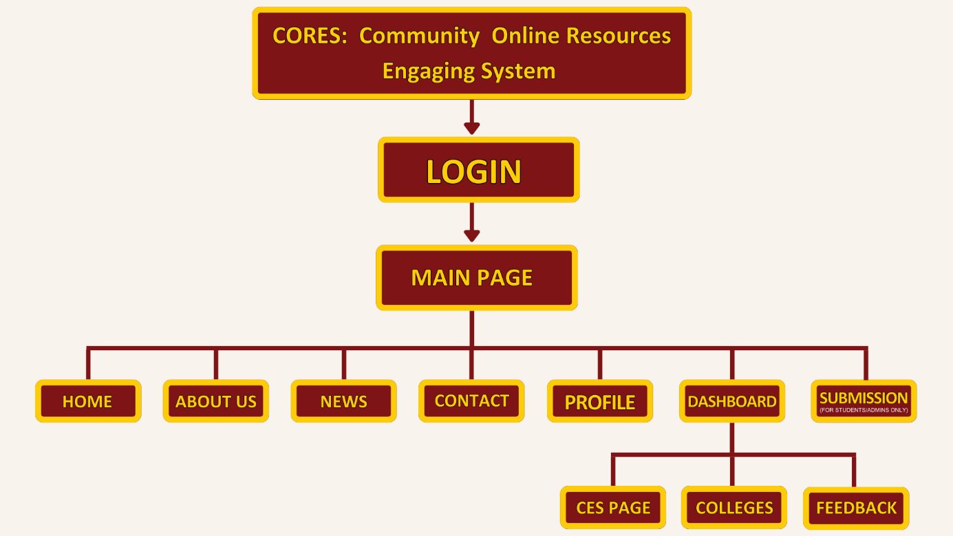

***Figure 3.2***  
**SYSTEM DESIGN**

Upon accessing the proposed website, end-users will be greeted with a user registration requirement, which involves logging in to the platform. This registration process ensures that users can navigate the system with a personalized identification and profile.

Once the login is successfully completed, users will be seamlessly redirected to the Main Page, serving as the central hub of the website. From here, they can effortlessly explore various sections, including Home, About Us, News, Contact, Profile, and Dashboard. The Dashboard offers additional sections for Colleges COP Documents, CES Page, and Feedback, catering to the diverse needs and interests of the user base.

For specific tasks, such as submissions, students and administrators will find an exclusive section, which is accessible only to them. This structured approach to the website's layout ensures a user-friendly experience, allowing seamless interaction and access to the site's core functionalities.

The CORES website offers varying levels of access and functionality to different user groups. Users, comprising individuals who visit the site, can explore its content and navigate through its pages but do not possess the authorization to make any alterations or modifications.

In contrast, students, particularly those affiliated with the College Student Council of the Department, including their COP Coordinator, enjoy an enhanced level of access. They have the privilege to upload and edit the content on their college page, as well as submit concept paper proposals for the conduction of Community Outreach Programs (COPs). Furthermore, they can engage in the exchange of feedback with Users, fostering interaction and collaboration.

At the highest tier of access, Administrations are entrusted with comprehensive control over the website. They hold the authority to make changes, edits, and updates to the entire content of the website, ensuring that it remains current and relevant to its users. This layered approach to access and functionality ensures that CORES operates effectively and efficiently, catering to the needs of its diverse user base.

**Encoding the System**

The encoding phase of a capstone project focused on creating a documentary website system is an essential stage in ensuring the overall success of the project. It serves as a critical bridge between the design concept and the actual implementation, streamlining the process for the back-end developers. To commence this phase effectively, the first step is to obtain the necessary approvals and finalize the system design. This acts as a foundational blueprint, enabling developers to code the system with structure and precision, ultimately facilitating smooth and successful execution.

With the design solidified, the next imperative task is to gather all the resources and information required for the website's content. This meticulous preparation equips developers with a comprehensive understanding of what needs to be presented on the website, minimizing any potential hiccups during the implementation phase. It ensures a seamless transition from concept to reality.

Once the design and content resources are in place, it's crucial to prepare the tools and materials needed for the encoding phase. These tools are the vital building blocks for processing the proposed system. For the software component, developers need to have essential materials such as phpMyAdmin/SQL, CSS, JavaScript, and Xampp at their disposal. On the hardware side, a computer with at least an i3 processor and 4GB of RAM is necessary to handle the development process efficiently. Once these hardware and software requirements are met, the developers are poised to commence the program encoding phase with confidence and readiness.

Upon the completion of the system and when it's fully prepared to run, the project moves into the testing phase. This stage is crucial as it allows for thorough checks and examinations to identify any potential errors or issues. Addressing these concerns before deploying the system is a key step in ensuring a polished and error-free final product. In summary, a systematic approach to the encoding phase, backed by careful planning, resource gathering, and the right tools, is vital in creating a successful documentary website system.

**TESTING**

The testing phase is a critical step in the development process as it enables developers to pinpoint areas for enhancement and thoroughly inspect the website for errors or issues before it undergoes evaluation by respondents or users. This phase acts as an extensive quality control process, guaranteeing that the website is not only operational but also user-friendly and devoid of any technical hiccups. It functions as a pivotal checkpoint, certifying that the product is refined and prepared for its intended audience.

**SYSTEM EVALUATION**

After the testing phase, the evaluation phase commences, playing a pivotal role in ensuring that all gathered data is effectively utilized. This data serves as a guiding beacon for enhancing the system and acts as a trigger point for ensuring that the system continuously aligns with the evolving needs of end-users and remains current with technological advancements. Within the ensuring precision phase, comprehensive testing is conducted on laptops and desktop devices to guarantee the system's full responsiveness and functionality across various platforms.

A survey will be gathered through Google Forms to collect user feedback regarding their system usage experience. This survey is distributed to a subset of end-users currently utilizing the system within the production environment. The responses obtained are thoroughly examined to pinpoint specific areas where enhancements can be made to the system. Subsequently, a comprehensive report is compiled, summarizing the outcomes of the evaluation and offering suggestions for potential future developments or improvements.

To determine the outcome of the data-gathering process, the following procedures are utilized to analyze, interpret, and present obtained information: Weighted Mean. An average in which some data points are given more weight in the calculation than others. The following formula will be used to calculate the results:

% = (f / n) x 100

Weighted Mean: 𝑥 = ∑ 𝑥/𝑛

where: % = Percentage

f = Frequency

∑ = Summation of score

n = Total number of respondents

𝑥 = Weighted Mean

**Likert Scale.** A questionnaire with a Likert scale is utilized to rate and evaluate the software. This is commonly used in survey research to measure and scale replies. The software is validated using ISO 9126 certification. Software Functionality, Reliability, Usability, Efficiency, Maintainability, and Portability are all areas for review.

|  |  |
| --- | --- |
| Range | Interpretation |
| 4.50 – 5.00 | Highly Satisfied |
| 3.50 – 4.49 | Satisfied |
| 2.50 – 3.49 | Neutral |
| 1.50 – 2.49 | Dissatisfied |
| 1.00 – 1.49 | Highly Dissatisfied |

***Table3.4*  
Likert Scale**

The evaluation criteria will be based on the numerical scale rating with 5 being the highest score and 1 being the lowest score. After rating each area, all values would have to be summed up and divided by the number of areas using a weighted means.

Developers will also use interviews for evaluating the system. They will formulate targeted questions aimed at understanding the administrator's experience. They will inquire about any preferences regarding additions or alterations to the system or website content. This interactive element adds a valuable dimension to the assessment process, ensuring that the system aligns seamlessly with the administrator's needs and desires. During this phase, we determine whether the system is ready for deployment. If further modifications or changes are needed, we'll go back to the system design stage. This process ensures that we refine the system before moving on to full implementation, emphasizing the importance of a thorough evaluation.

**IMPLEMENTATION**

The implementation phase is a stage in a project where the plans and designs are put into action. It's the step where the actual development, construction, or execution of a system, project, or idea occurs, based on the previously established blueprints and specifications. This phase involves turning concepts into tangible results, such as coding and building a software system, constructing physical structures, or executing strategies, to bring the project to life.

**Security Design**

In modern times, having robust security features in place has become a standard practice. These measures are essential for safeguarding the security and integrity of any system. Implementing a strong password policy stands as one of the initial lines of defense. by requiring a minimum password length and the inclusion of a variety of character types, which is crucial for enhancing security. Encryption stands as another vital measure to protect sensitive information, including login credentials and all stored data within the system. Consistent monitoring and auditing play a pivotal role in detecting and preventing unauthorized access. Keeping the software updated with the latest versions is crucial for ensuring that security features remain current and that security patches are applied as needed.

References:

1. *What are the browser and computer requirements for Instructure products?* (2023, August 17). <https://community.canvaslms.com/t5/Canvas-Basics-Guide/What-are-the-browser-and-computer-requirements-for-Instructure/ta-p/66>